Attacktive_Directory_Solution_Documentation
Written by: Yuval Quina
This is my first windows machine ctf.
I started this challenge by executing an Nmap scan:
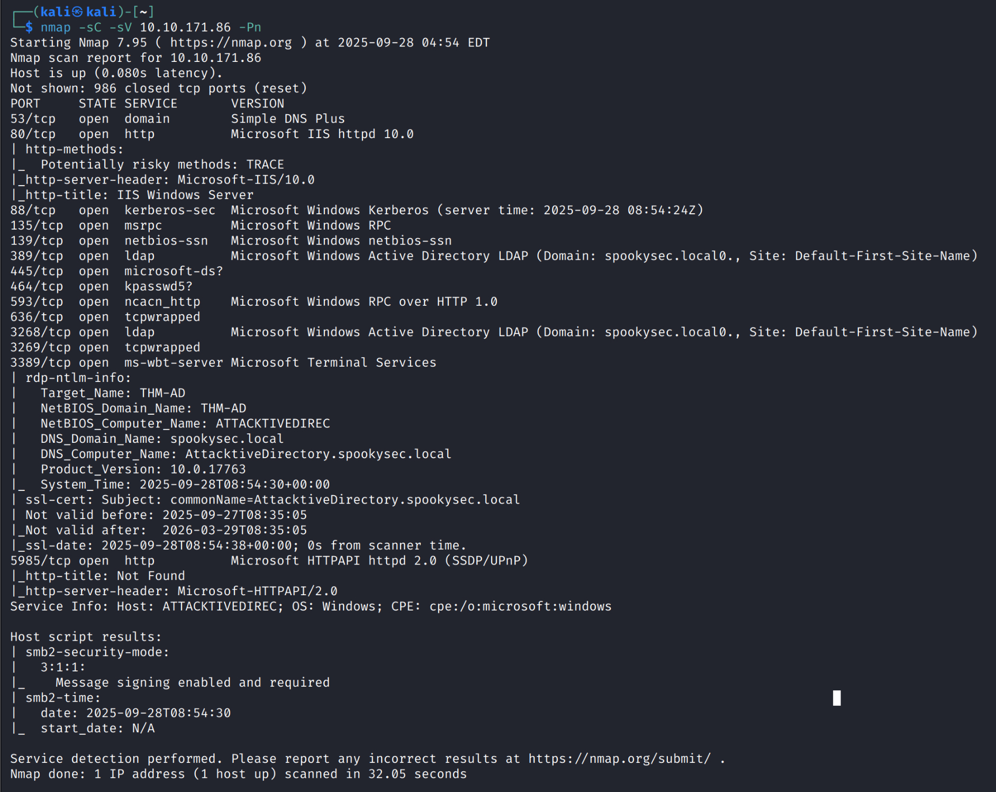
I saw that this target has many open ports and services.
Then I moved to enumerate data from the windows target using “enum4linux” (which is a tool to retrieve data from windows machines based on SMB protocol):
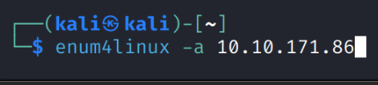
I found out what the NetBIOS-domain name of this machine is:
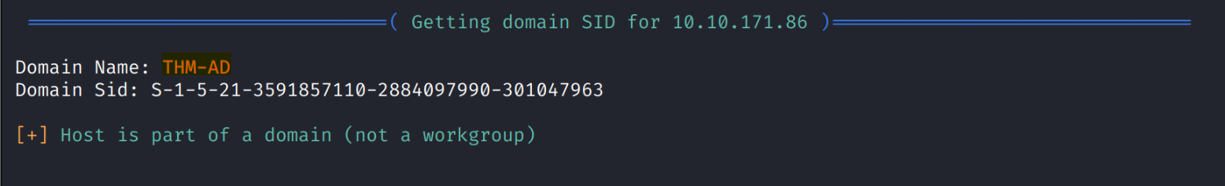

Afterwards, I moved to bruteforce credentials on the Kerberos (a computer network authentication protocol used in active directory) using the tool “Kerbroute”. The thm page of this challenge gave me the usernames and passwords wordlists files which I downloaded using “wget”:
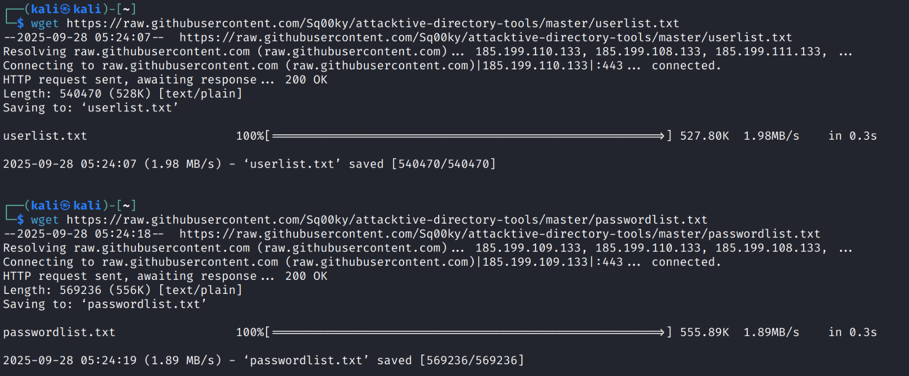
The command that I used to execute the bruteforce attack and the users that I found:
